**\*1. Total loan applications \***

select count(id) as Total_loan_applications from financial_loan;



**\*2. MTD loan applications\***

select count(id) as MTD_loan_applications from financial_loan

where month(issue_date)=12;



**\*3. PMTD loan applications\***

select count(id) as PMTD_loan_applications from financial_loan

where month(issue_date)=11;



**\*4. total funded amount\***

SELECT SUM(loan_amount) AS Total_Funded_Amount FROM financial_loan;



**\*5. MTD total funded amount\***

select sum(loan_amount) as MTD_Funded_Amount from financial_loan

where month(issue_date)=12;



**\*6. PMTD total funded amount\***

select sum(loan_amount) as PMTD_Funded_Amount from financial_loan

where month(issue_date)=11;



**\*7. Total amount received\***

select sum(total_payment) as Total_amount_received from financial_loan;



**\*8. MTD Total amount received\***

select sum(total_payment) as MTD_Total_amount_received from financial_loan

where month(last_payment_date)=12;



**\*9. PMTD Total amount received\***

select sum(total_payment) as MTD_Total_amount_received from financial_loan

where month(last_payment_date) =11;



**\*10. Average interest rate\***

select AVG(int_rate)*100.0 as avg_interest_rate from financial_loan



**\*11. MTD Average interest rate\***

select AVG(int_rate)*100.0 as MTD_avg_interest_rate from financial_loan

where MONTH(issue_date) = 12;



**\*12. PMTD Average interest rate\***

select AVG(int_rate)*100.0 as PMTD_avg_interest_rate from financial_loan

where MONTH(issue_date) = 11;



**\*13. avg debt to income ratio\***

select AVG(dti)*100.0 as Average_DTI from financial_loan;



**\*14. MTD avg debt to income ratio\***

select AVG(dti)*100.0 as MTD_Average_DTI from financial_loan

where month(issue_date)=12;



**\*15. PMTD avg debt to income ratio\***

select AVG(dti)*100.0 as PMTD_Average_DTI from financial_loan

where month(issue_date)=11;



**\*16. good loan applications\***

select COUNT(id) as Good_loan_applications from financial_loan where loan_status !='Charged Off';



**\*17. bad loan applications\***

select COUNT(id) as bad_loan_applications from financial_loan where loan_status ='Charged Off';



**\*18. good loan applications percentage\***

select count(CASE when loan_status !='Charged Off' then id end )*100.0 /COUNT(id)as Good_loan_applications_percentage from financial_loan;

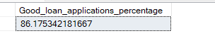

**\*19. good loan funded amount\***

select sum(loan_amount) as good_loan_funded_amount from financial_loan where loan_status !='Charged Off';



**\*20. good loan total received amount\***

select sum(total_payment) as good_loan_received_amount from financial_loan where loan_status !='Charged Off';



**\*21. bad loan applications percentage\***

select COUNT(case when loan_status='Charged Off' then id end)*100.0 /count(id) as bad_loan_applications from financial_loan;



**\*22. bad loan funded amount\***

select sum(loan_amount) as bad_loan_funded_amount from financial_loan where loan_status ='Charged Off';



**\*23. good loan total received amount\***

select sum(total_payment) as bad_loan_recieved_amount from financial_loan where loan_status ='Charged Off';



**\*24. monthly trends by issue date\***

select

MONTH(issue_date)as month_number,DATENAME(MONTH,issue_date) as month_name,

count(id) as Total_loan_applications,

sum(loan_amount) as Total_Funded_amount,

sum(total_payment) as Total_amount_received from financial_loan group by month(issue_date), DATENAME(month,issue_date) order by MONTH(issue_date) ;

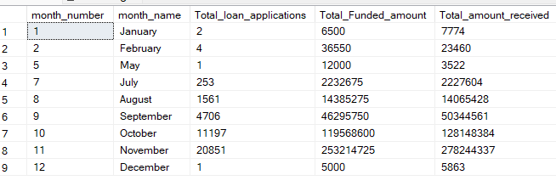

**\*25. regional analysis by state\***

select

address_state as State,

count(id) as Total_loan_applications,

sum(loan_amount) as Total_Funded_amount,

sum(total_payment) as Total_amount_received from financial_loan group by address_state order by address_state;

**\*26. loan term analysis\***

select

term,

count(id) as Total_loan_applications,

sum(loan_amount) as Total_Funded_amount,

sum(total_payment) as Total_amount_received from financial_loan group by term order by term;

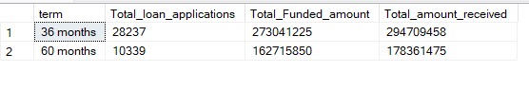

**\*27. employee length analysis\***

select

emp_length,

count(id) as Total_loan_applications,

sum(loan_amount) as Total_Funded_amount,

sum(total_payment) as Total_amount_received from financial_loan group by emp_length order by emp_length;

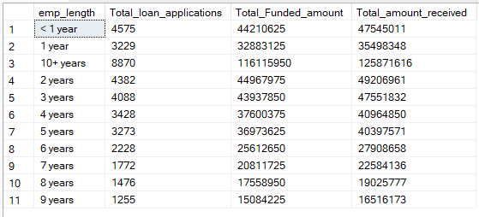

**\*28. loan purpose breakdown analysis\***

select

purpose,

count(id) as Total_loan_applications,

sum(loan_amount) as Total_Funded_amount,

sum(total_payment) as Total_amount_received from financial_loan group by purpose order by purpose;

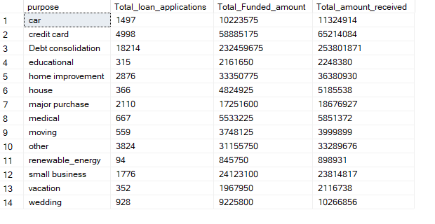

**\*29. home ownership analysis\***

select

home_ownership,

count(id) as Total_loan_applications,

sum(loan_amount) as Total_Funded_amount,

sum(total_payment) as Total_amount_received from financial_loan group by home_ownership order by count(id);

